2/23 Meeting Notes

- We should check with Rachel on relevant parameters, but not necessarily useful to show her exactly how we’re tricking the software to work according to Schwartz.

Propane data
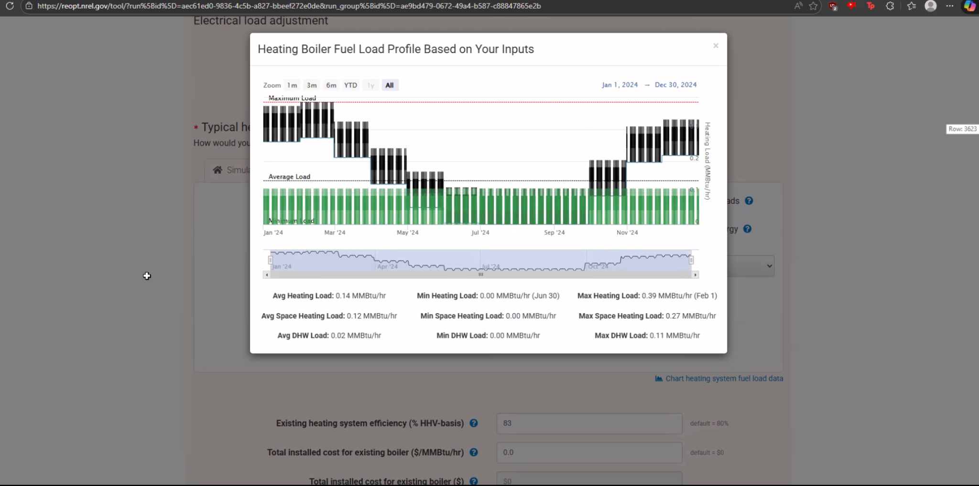
- Each month has an average temperature for the month, Mick kept everything constant throughout the month. Wasn’t sure how precise we need to be.
- Schwartz says probably do it weekly - average weekly or daily temperatures and average energy use per week.
  - Should still end up at the same average monthly amount, but spread across the month instead of a constant temperature.
- Potentially would need daily minimum and daily maximum to do flex events. Get daily data and decide to scale up to weekly or keep it daily, if we want to.
  - Data should vary by week or day to have a much more realistic fixture of how energy is used.
  - Could downscale MMBtus as well
- Assume electric resistive boiler close to 97% efficiency, different from propane boiler (83%) and all Btus come through meter as kWh instead of gallons of propane
- Look into process of replacement
  - Air over water heat exchanger was designed for 195 degree water. The same amount of heat transfer area with 135 degree water (used in electric resistive heating) may require replacement. Will be part of design next quarter. What is the additional heat transfer equipment needed, estimated costs?

Utilities
- Net metering vs. net billing - varies, someone dictates terms to us. Depends on who pays for solar panels.
  - Look into the Flex program - see email from Rachel.
  - Figure out net billing information - see how this might be covered. This depends on the source of payment.
  - To account for Flex, we are going to have to trick the ReOpt inputs (see Battery section)

Financial:
- 10 year analysis if battery involved
- Host discount rate - nominal, inflation, 2.5%
- In terms of rates (like propane rate), use numbers that make business as usual look bad but are also defendable.
- Variance of fossil fuels is a major issue, one of the main reasons to move away from it. We see that in the constantly changing rates in Ferrell Gas data.
- He says go with a reasonably supported rate, note that this is kind of a “fake” number
- Really want to focus on things where we are lacking confidence

Battery Info
- How long does the battery take to discharge? ReOpt assumes 2 hours
  - Not independent numbers, related to battery design itself
  - Basic assumption built into NREL numbers
- Need to look at pricing/info from Rachel to estimate battery pricing
- Schwartz says don’t show any outputs yet, try not to make it seem like we have a thorough design yet.
- Total power capacity rebate: For battery, Rachel says there is a cap on initial amount they can get. Schwartz says we need to trick the software to make this work. Upfront case flow, then add up number of flex events.
- Find out over 10 years how much we would get from flex and how much the battery would degrade. That way, we can analyze cost of having to replace the battery.
- Sammy probably needs to meet with Dr. Schwartz to talk about ways to trick ReOpt into using Flex
- Electric power is becoming very limiting for industry. Tremendous growth in electric demand, so having people manage power using batteries is really important.
- Figure out economics of battery

ASHP
- Could use default total installed cost instead of $0.01/ton to figure out how much needs to be covered by grants. Or make estimate?
- Don’t ask Rachel about the O&M cost increase, maybe look into handbooks, research this number. Could call someone that knows about this - e.g., McKinstry (might be spelled wrong?)
- Don’t ask Rachel about the first four bullet points or 10 degree resistive limit at least (not sure if we need to tell her about others). Be selective on what we ask her about so we just ask about things she might have an opinion about.
- Keep 10 degree default for resistive heating

